Final Project Proposal

By: Bharath Palanisamy, Joseph Mackie, Borjana Veliu, Hishaam Ahamad

**Part 1: Final Project proposal**

**Team members**: Hishaam Ahamad, Joseph Mackie, Bharath Palanisamy, Borjana Veliu

**Project name**: Interview Registration system

**Abstract**- The interview reservation system will allow companies and candidates to agree upon an interview date and time. The system will allow the company and candidates to share their availability. At that time a scheduling service can send suggested dates and times to the candidate and the candidate can choose and interview time. The system will also allow integration with Google Calendar or another calendar system so users can see appointments in their calendar. If anyone needs to change the date or time of the scheduled appointment, they can interact with the system to find and propose a new date or time. Interviews can also be canceled by either party and they can specify the reason for the cancellation. Alerts will be sent by the system through email. Reporting will be available as well so parties can see a full view of their interviews.

**Objectives**: Interview Request, Interview Confirmation, communications, company, candidate, scheduling, calendar integration, alerting, change (cancel/change date), reporting, and authentication and authorization

**Schedule**: setting up Kubernetes - 7/18

setting up docker hub - 7/18

GitHub actions basic pipeline - 7/19

general architecture - 7/20

setup Kafka - 7/21

security - 7/23

communications - not done

Gatekeeper - 7/23

candidate - 7/29

scheduling - not done

calendar integration - not done

Powerpoint - 8/2

Availability - 8/2

testing - 8/2

report – 8/3

List of Technologies will be used: python, flask, Kafka, docker hub, docker, Kubernetes, PostgreSQL

**Part 2: Process Flows**

Here is the GitHub link where the process flows for our project.

<https://github.com/hishaam19/CSC5991/blob/main/Documentation/ProcessFlows.pdf>

**Part 3: Project Outcomes**

Allowing companies and candidates to agree upon an interview.

Allowing the company and candidates to share their availability.

Allowing integration with Google Calendar.

Canceling or editing an interview.

Reporting the interviews scheduled.

**Part 4: Screenshot of our outcomes**

**Part 5: Goals achieved and remaining goals**

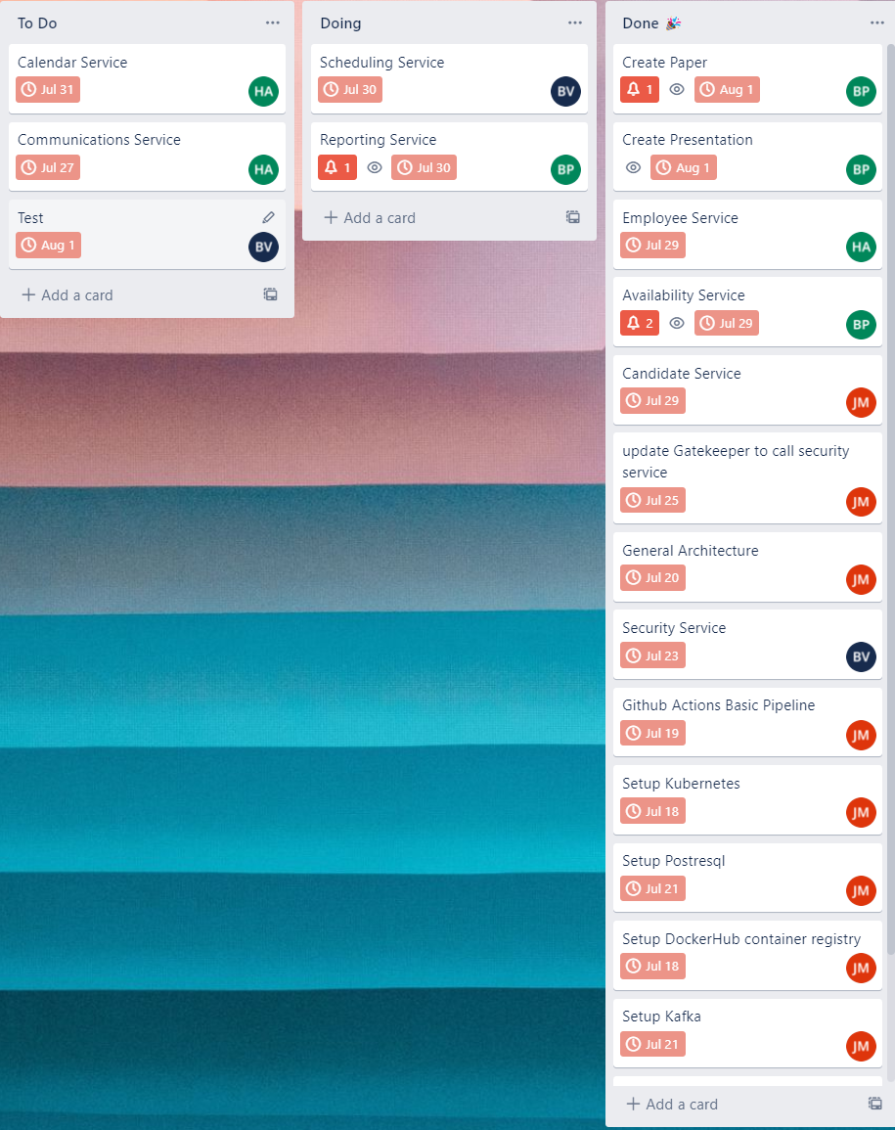

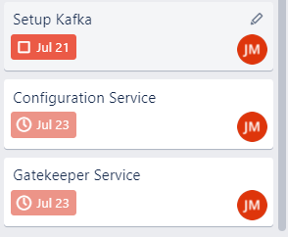

The remaining goals we have is implementing most of the service, such as scheduling, employee, availability service, and so forth. We still have these services left because We didn’t implement them correctly. When we were trying to merge github branches with main, we kept getting errors in the merging process such as this error message. That was the major reason why we couldn’t merge the code to check to see if the code was working on the cloud of oketeo. So far the achieved goals we’ve done, which is setting everything up which Joe did. Joe set up PostgReSQL, Kafka, Kubernetes, oketo, and DockerHub. So in conclusion, the goals we set up were reasonable. Other than Joe and Borjana, we didn’t really know how to implement everything correctly.

ERROR: Could not find a version that satisfies the requirement click==8.1.3 (from versions: 0.1, 0.2, 0.3, 0.4, 0.5, 0.5.1, 0.6, 0.7, 1.0, 1.1, 2.0, 2.1, 2.2, 2.3, 2.4, 2.5, 2.6, 3.0, 3.1, 3.2, 3.3, 4.0, 4.1, 5.0, 5.1, 6.0, 6.1, 6.2, 6.3, 6.4, 6.5, 6.6, 6.7.dev0, 6.7, 7.0, 7.1, 7.1.1, 7.1.2, 8.0.0a1, 8.0.0rc1, 8.0.0, 8.0.1, 8.0.2, 8.0.3, 8.0.4)

**Part 6: Team member contributions and roles**

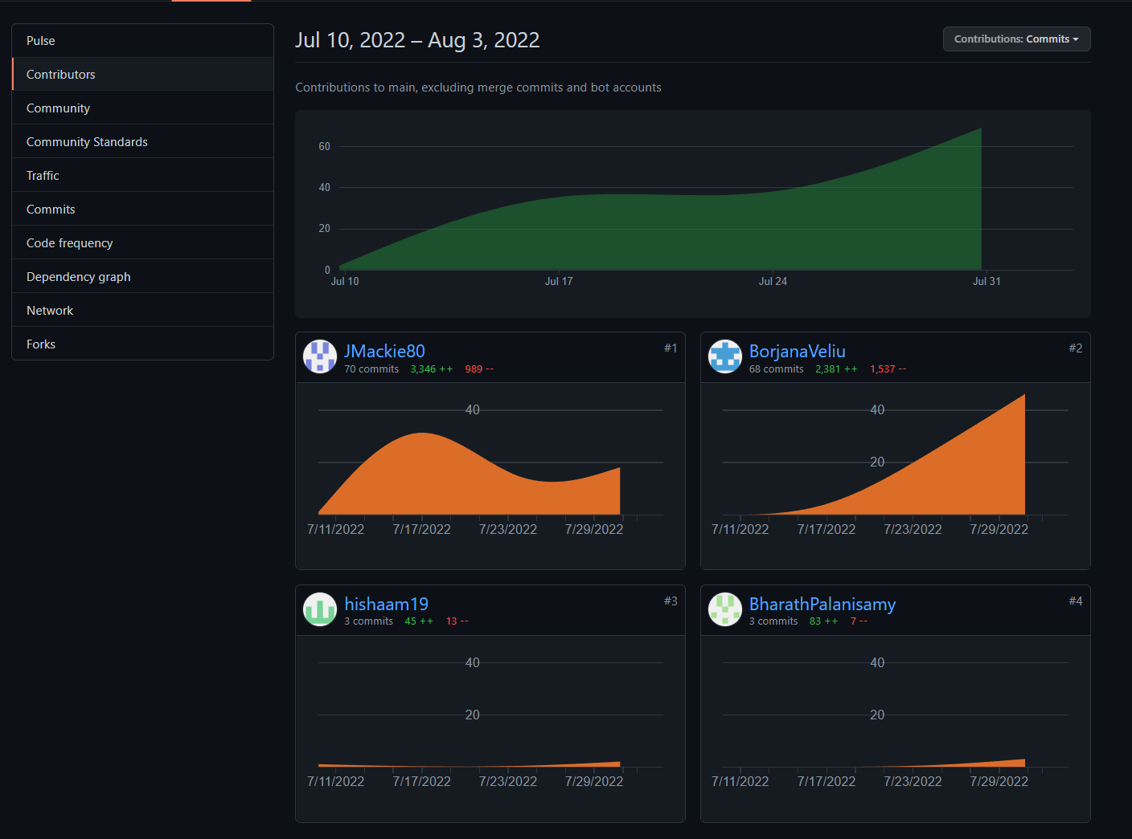

**Team Role:**

Joe - team lead, set up all the services, candidate service, configuration service, Process flows, network diagram, and powerpoint

Bharath - reporting and availability service, paper

Hishaam - Communication service, employee service and calendar service

Borjana - Scheduling service, security service, and testing

Is all shown in the picture above. You can see what every single person did so far, as well as all the roles assigned to each person.

**Part 7: GitHub, Trello (or the agile tool we used), and container registry address**

[**https://trello.com/b/8ts8WKw6/group-4-final-project**](https://trello.com/b/8ts8WKw6/group-4-final-project)

[**https://kafka-ui-service-infrastructure-jmackie80.cloud.okteto.net/**](https://kafka-ui-service-infrastructure-jmackie80.cloud.okteto.net/)

[**https://pgadmin-infrastructure-jmackie80.cloud.okteto.net/**](https://pgadmin-infrastructure-jmackie80.cloud.okteto.net/)